Practical no. 1
Name :- Danish Altaf Solkar Enrolment no. :-24111590805
Class :- CO3K – B Subject :- OOP
Aim :- To evaluate following expression using input output function:
y= 5*x-5
Program :-
#include<iostream.h>
#include<conio.h>
void main()
{
int x, y;
clrscr();
cout<<"Enter value of x :-";
cin>>x;
y=5*x-5;
cout<<"\nValue of y is :- "<<y;
getch();
}
OUTPUT :-
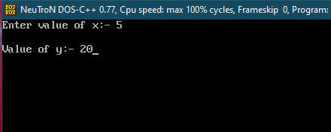
Aim :- To print “hi” msg if entered value is more than 10 otherwise print “bye” msg on output screen.
Program :-
#include<iostream.h>
#include<conio.h>
void main()
{
int no;
clrscr();
cout<<"Enter a number :- ";
cin>>no;
(no>10)?cout<<”HII” : cout<<”BYE”;
getch();
}
OUTPUT :-
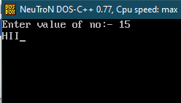
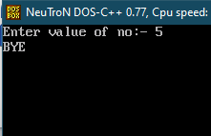

Aim :- To print largest number among two number using Conditional operator.
Program :-
#include<iostream.h>
#include<conio.h>
void main()
{
int num1,num2;
clrscr();
cout<<"Enter value of num1 :- ";
cin>>num1;
cout<<"\nEnter value of num2 :- ";
cin>>num2;
(num1>num2)?cout<<"\nLargest no. is "<<num1:cout<<"\nLargest no. is "<<num2;
getch();
}
OUTPUT :-
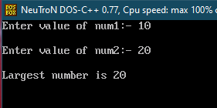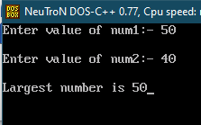

Practical Related Questions :-
Write a C++ program to evaluate the following expressions:
X=(-b-(b2 -4ac))/2a
Program:-
#include<iostream.h>
#include<conio.h>
void main()
{
int x,b,a,c;
clrscr();
cout<<"Enter value of a :- ";
cin>>a;
cout<<"\nEnter value of b :- ";
cin>>b;
cout<<"\nEnter value of c :- ";
cin>>c;
x=(-b-(b*b-4*a*c))/2*a;
cout<<"\nValue of X is "<<x;
getch();
}
OUTPUT :-
